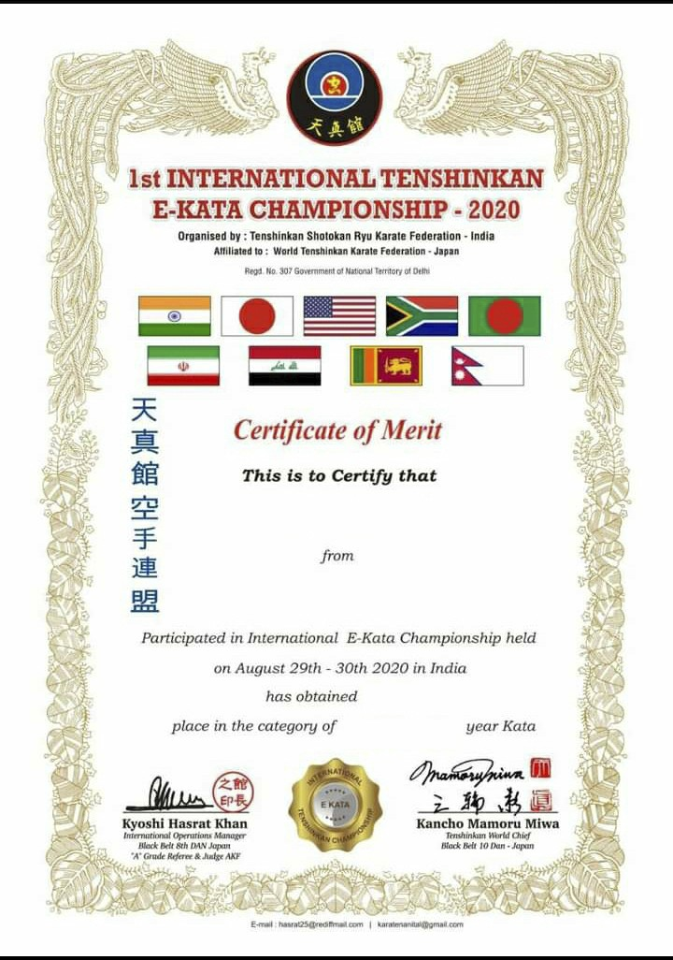

YOGRAJ KUMAR

BIHAR, INDIA

1ST

MALE- U/14